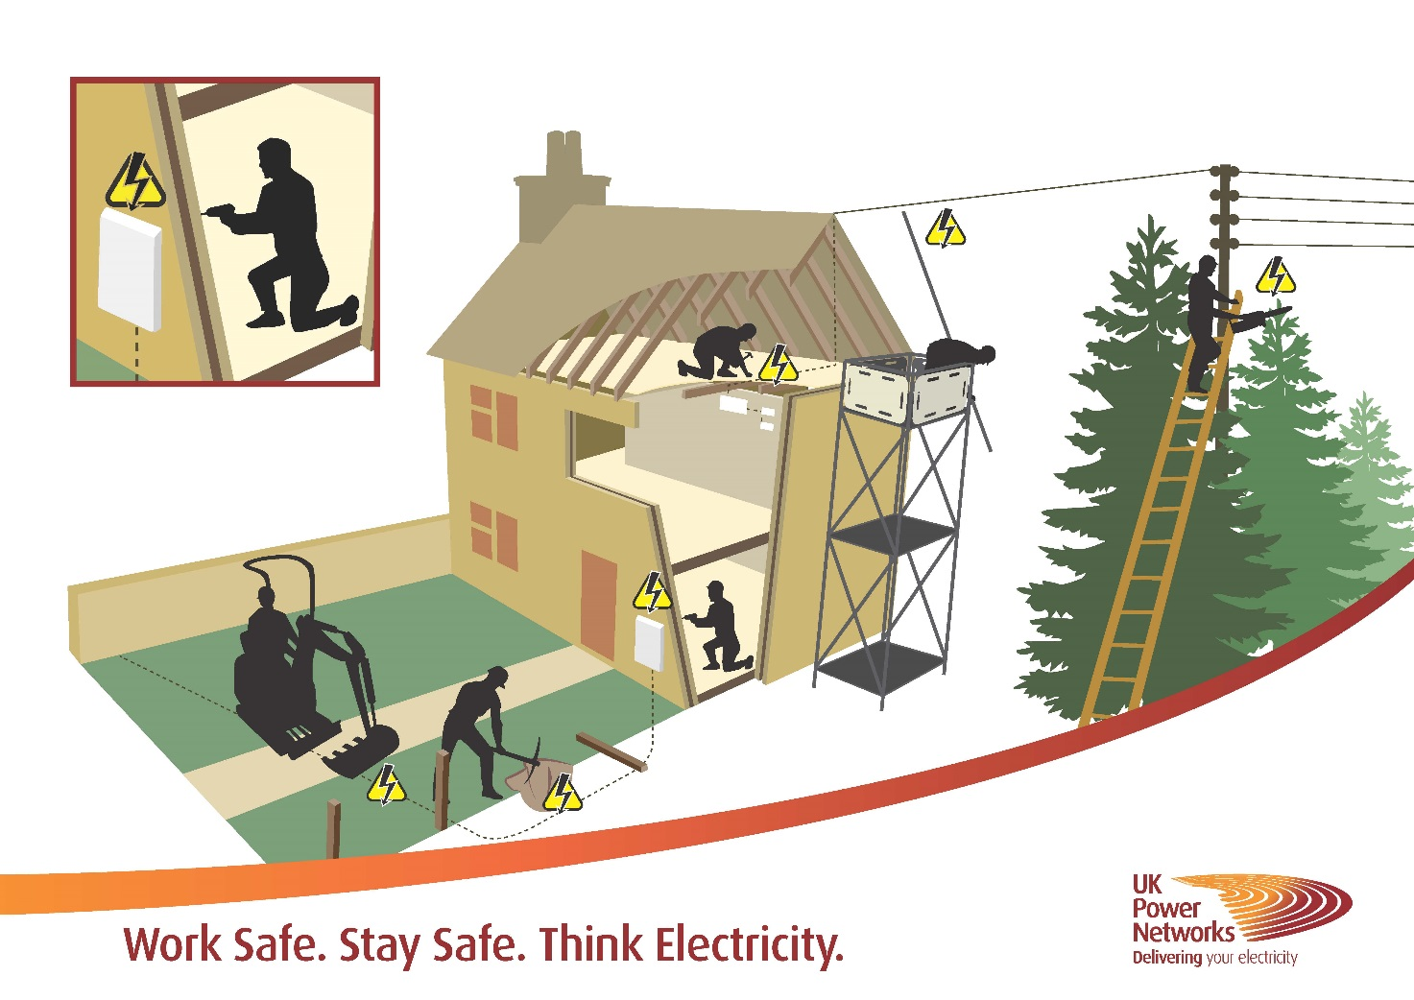

Sadly, life can be lost within seconds or terrible life-changing burns inflicted, if you come into contact with electricity and that’s why we want to help.

Here at UK Power Networks we are running a ‘Work Safe. Stay Safe. Think Electricity’ initiative, reminding workers, to use your cable locating tools and think electricity!

IN 2015/16 over 70,000 trades people suffered injuries at work. More often this results in taking time off and losing money. How would this effect you and your family?

It can be all too easy for busy trades people including electricians, fencers and tree cutters, to be in a hurry, get distracted or not bother to check for high voltage cables when working on site – I’m sure at times we all just zone out for a few seconds, or plain forget things.

Electricity service cables are not always visible, they can be hidden or out of sight.

The simple step of taking a moment to accurately locate service cables buried underground, behind walls or under floorboards before starting work ultimately means you return home safe that night to your family and friends.

**Think Ahead**

**Your Distribution Network Operator can advise you!**

Get the basics right. Plan it out and obtain relevant cable plans from your Distribution Network Operator or Independent Distribution Network Operator and ensure they are shown to and understood by those on site BEFORE starting work.

They can advise you on what steps to take if essential work is necessary close to buried service cables and overhead lines and can help ensure safe working practices are implemented.

**WHAT TO DO IN AN EMERGENCY**

**If a mains service cable is damaged STOP WORK** immediately.

Notify YOUR Distribution Network Operator immediately:

**Dial 105** or 0800 056 105

If you damage a cable, stay calm, keep clear and call for help.

**Call the emergency services** if anyone is injured. Anyone who has received an electric shock should go to hospital as damage may have occurred to the heart.

Always **treat the cable(s) as live** even if they are not sparking. Cables can be re-energised at any time without warning.

**Never remove** anything that is stuck or in contact with cable.

**Keep everyone well away** from the area of damage.

Our vast cable networks deliver more than a quarter of the UK’s electricity making sure the lights stay on across London, the South East and the East of England. We’re proud of our strong safety record. Everyone has the right to go home safe to their families at the end of each working day.

Please take the time to read the safety advice on our website, download your free safety leaflets, and most importantly, ‘Work Safe. Stay Safe. Think Electricity’

**For more information on electrical safety, and to request your free vehicle safety cab sticker or dig sticker for machinery and equipment you operate visit** [**UK Power Networks**](http://www.ukpowernetworks.co.uk/internet/en/safety/)

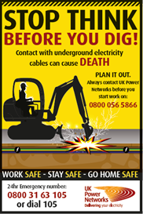 [](http://www.ukpowernetworks.co.uk/internet/en/safety/) 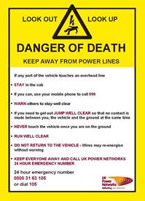

|  |  |  |
| --- | --- | --- |
|  |  |  |
| |  | | --- | | **Who are UK Power Networks?**  UK Power Networks distributes more than a quarter of the UK's electricity through its networks of substations, underground cables and overhead lines making sure the lights stay on across London, the South East and the East of England, regardless of who customers pay their energy bills to. A range of other companies deliver power to the rest of the country.  For more information visit our [**website**](http://www.ukpowernetworks.co.uk/) | | | |
| |  |  |  |  |  |  |  |  |  |  |  |  |  | | --- | --- | --- | --- | --- | --- | --- | --- | --- | --- | --- | --- | --- | | |  |  |  | | --- | --- | --- | | **Follow us** | | | | [cid:image004.jpg@01D1D131.BFAE9F30](https://twitter.com/UKPowerNetworks) | [cid:image005.jpg@01D1D131.BFAE9F30](https://twitter.com/ukpnnews) | [cid:image006.jpg@01D1D131.BFAE9F30](https://www.facebook.com/ukpowernetworks) | | [cid:image007.jpg@01D1D131.BFAE9F30](http://uk.linkedin.com/company/uk-power-networks-) | cid:image008.jpg@01D1D131.BFAE9F30 | | | cid:image009.jpg@01D1D131.BFAE9F30 | UK Power Networks Holdings Limited  Registered office: Newington House, 237 Southwark Bridge Road, London SE1 6NP. Registered number: 7290590 registered in England and Wales | [cid:image010.jpg@01D1D131.BFAE9F30](http://www.ukpowernetworks.co.uk/) | | | |